1. Some times we get a situation to update the data
2. To update the data in documents below is the syntax:

Let see the below screen shot:

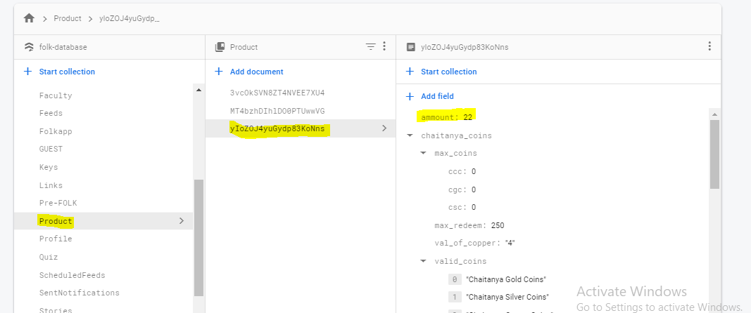

1. To update the amount value 22 to 30 in the document refer below code:
2. data = {

“amount”:30

}

doc_ref = db.collection(u’Product’).document(‘yIoZOJ4yuGydp83KoNns’)

doc_ref.update(data)

1. the data is updated referbelow screenshot

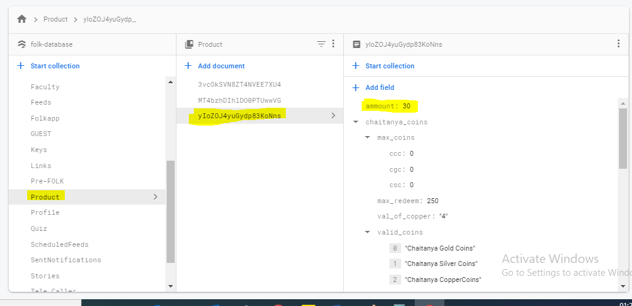

1. The below data is updated, similarly we can update string , Boolean,intezer values with similar syntax